**SSL Report Team-5**

**Introduction**

The purpose of an automated payroll application is to keep track of the attendance as well as payroll(salary) of the employees in an organization. This application should track whether the employee is within the office premises by obtaining the GPS location of the employee after every 10 seconds. This application helps the employer to prevent proxy attendance of the employee. Moreover, the HR of the company can easily calculate the payroll of the employee.

The project required the following features to be implemented:

* The location of the employee needs to be tracked.
* The image of the employee needs to be taken while logging in and logging out.
* The HR should be able to calculate the salary of the employee based on the location.
* The admin can add employee and HR. He/ She can reset the password of the employee.
* The HR should be able to set the salary of the employee.
* The HR and admin can we view the location details of the employee as well as the login and logout images of the employee.

**Software Architecture:**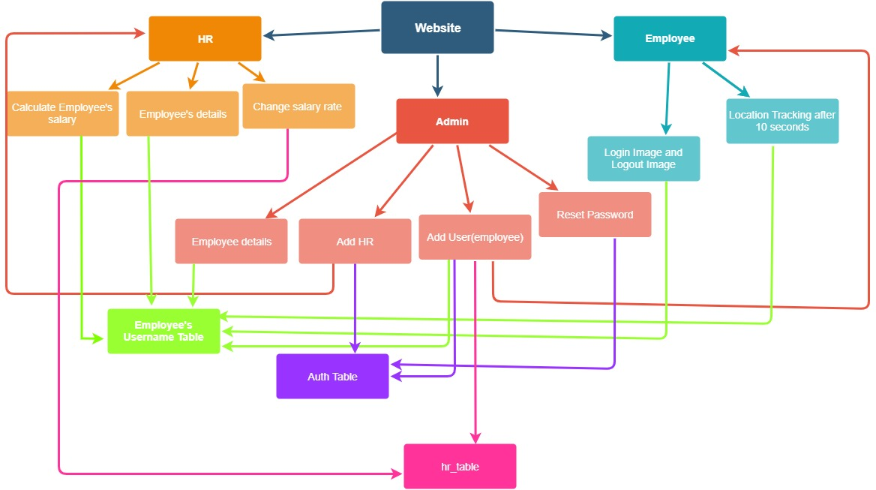

**Solution/ Implementation**

The project was built using the following:

1. HTML5 Geolocation API
2. HTML Getusermedia API
3. Backend: PHP, MySQL
4. Frontend: HTML, Bootstrap 4

**Admin Account:**

1. The admin account shows the number and names of employees registered in the company.
2. On clicking on the name of the employee the admin can know the location details of the employee on the map as well as can calculate the salary of the employee. Moreover, the admin can also change the password of the employee by clicking the reset password button.
3. The admin can add user by clicking the Add User button. Then a new sql table will be created with the username. Moreover, in the auth table the username of the user gets added.
4. The admin can add HR by clicking the 'Add HR' button. Then in the 'hr_table' the username of the HR gets added. Moreover, in the auth table the username of the HR gets added.
5. By clicking on 'Filter' button in navbar, the admin can search the employee by his/her name to know more about the employee and also know which employees were present on a particular date by selecting the date.

Before logging out of the admin account make an account of an HR by clicking on the Add HR and filling his/her necessary details and then clicking Join. Moreover, also add a user by clicking on the Add User and then filling his/her necessary details and then clicking Join. Then logout from the admin account.

**HR Account:**

1. The HR account shows the number and names of employees registered in the company.
2. On clicking on the name of the employee the HR can know the location details of the employee on the map as well as can calculate the salary of the employee. Moreover, the HR can see the login and logout images of the employee for each date.
3. The HR can change the salary rate of the employee by entering the new salary rate in the text box on his/her home page and then clicking submit button.
4. By clicking on 'Filter' button the admin can search the employee by his/her name to know more about the employee and also know which employees were present on a particular date by selecting the date.

Then logout from the HR’s account.

**Employee Account:**

1. As soon as the employee logins his/her image is taken. The address where the login image is stored, is then stored in employee's username table.
2. After every 10 seconds the employee's location is tracked using GPS and then the latitude and longitude is stored in the employee's username table.
3. When the employee clicks on logout button then his/her image is taken. The address where the logout image is stored is then stored in employee's username table.

**Directory Structure:**

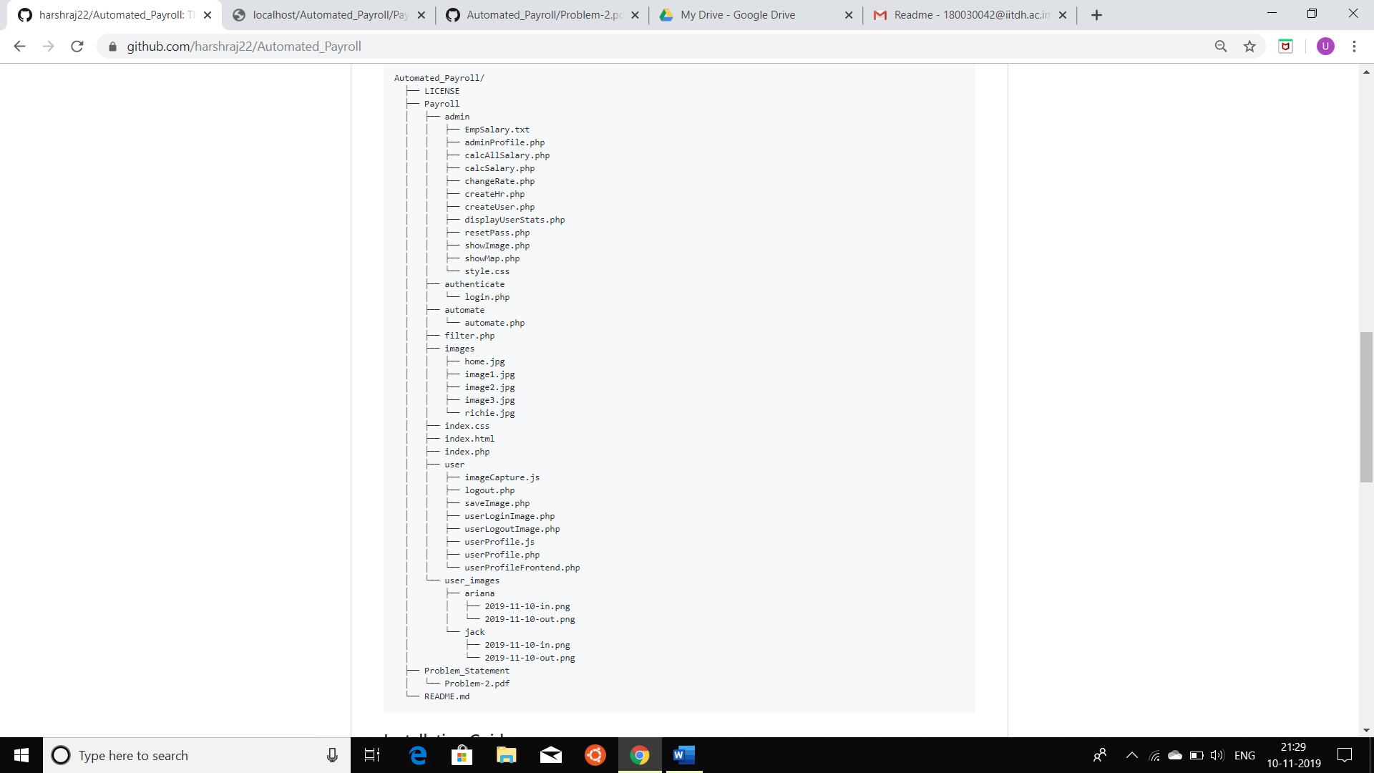

**Calculation of Salary:**

The HR sets the salary (salary per unit time) of the employee. Then we calculate the time for which the employee was logged in during the entire month and then we multiply this quantity by the salary. While calculating the time for which the employee was logged in, we also take into account that location of the employee was as desired.

**Result:**

We were successfully able to implement the following features in our project:

* The location of the employee is accurately tracked.
* The image of the employee is successfully taken while logging in and logging out.
* The HR is able to calculate the salary of the employee based on the location.
* The admin has option to add employee and HR. He/ She can reset the password of the employee.
* The HR is able to set the salary (salary per unit time) of the employee.
* The HR and admin can we view the location details of the employee as well as the login and logout images of the employee.

Our project seems to be industry ready satisfying all basic needs for automating the calculation of payroll task for any organisation.